Differential Manchester Encoding — Fundamentals
The key concept: Differential Manchester is a self-clocking, differential line code where the clock is embedded in the signal itself and data is encoded in the presence or absence of a mid-bit transition, not in the signal level.
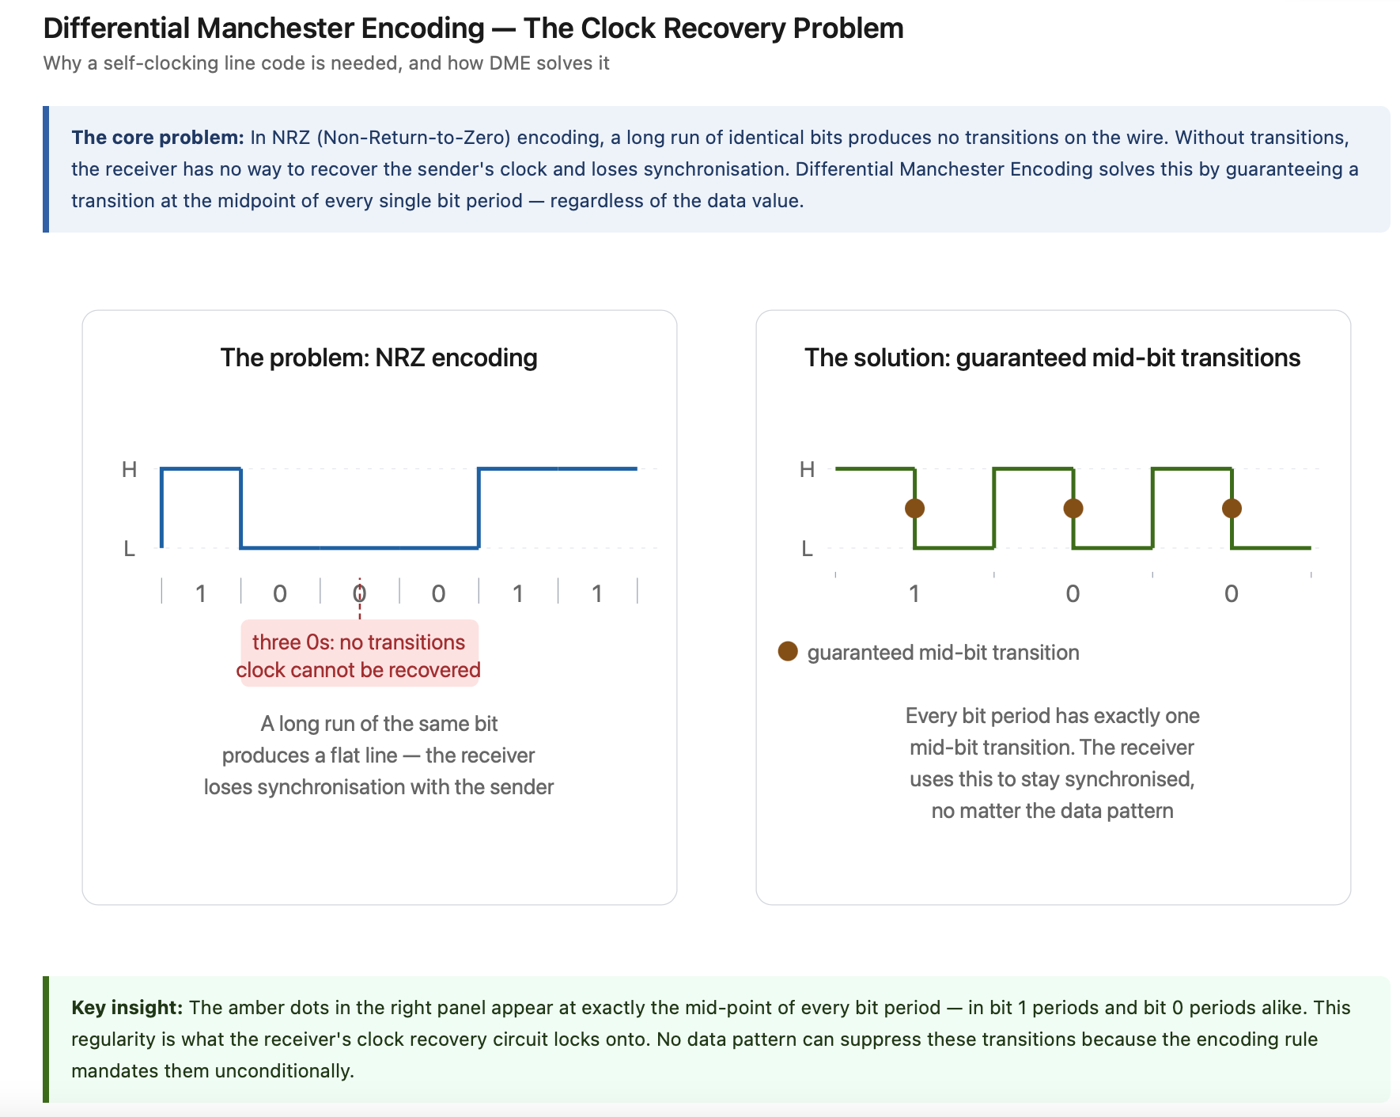
Full explanation with multiple diagrams, going from first principles through to the complete encoding.

The two rules of Differential Manchester Encoding
DME has exactly two rules, applied at every bit boundary:
Rule 1 — the mid-bit transition. Every bit period has a mandatory transition at the centre of the period. This is unconditional. It is what makes the encoding self-clocking — the receiver can always find the clock edge.
Rule 2 — the start-of-period transition encodes the bit. If the current bit is a 0, there is an additional transition at the start of the period (at the bit boundary). If the current bit is a 1, there is no transition at the start of the period. The signal simply continues at whatever level it was at the end of the previous bit.
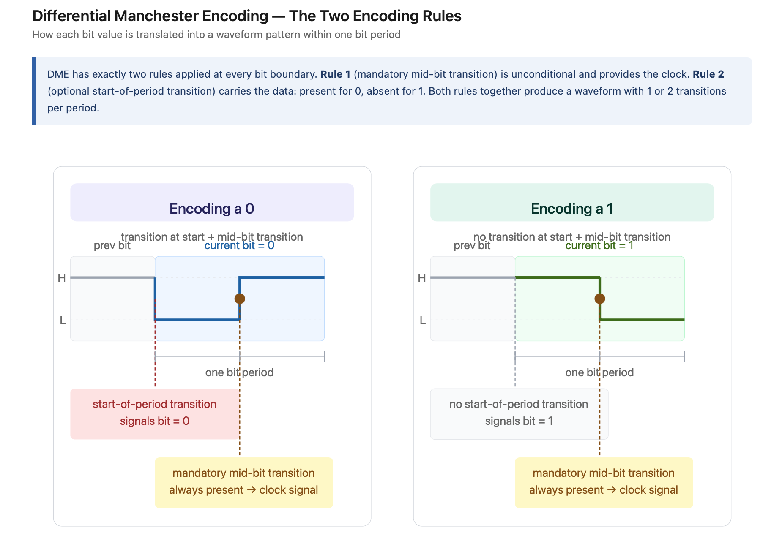
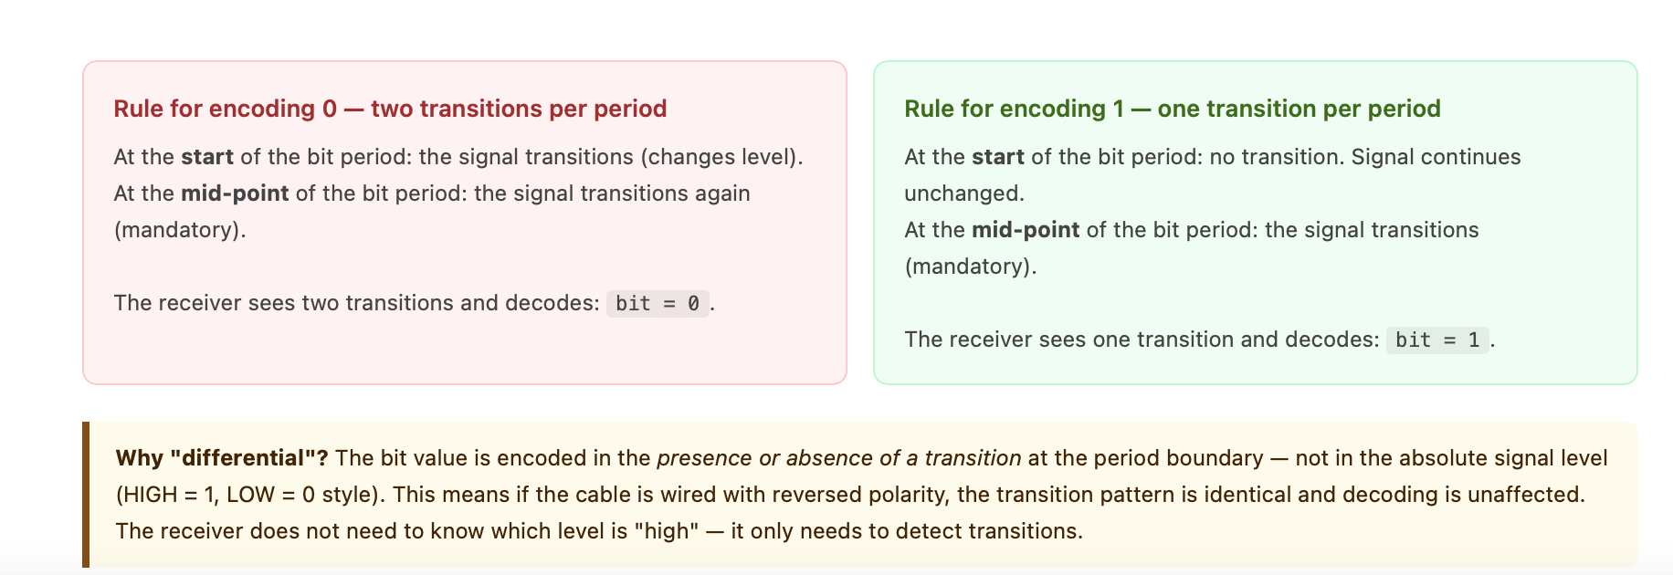
The critical insight that distinguishes Differential Manchester from plain Manchester is in rule 2: the bit value is encoded in the presence or absence of a transition, not in the direction of the mid-bit transition. This makes it immune to polarity inversion — if the cable is wired backwards, the data is still correctly decoded.

Notice a subtle but important consequence: the direction of the mid-bit transition (whether it goes H→L or L→H) is not what carries the data. It simply depends on what state the signal was in. The receiver need only ask "was there a transition at the start of this period?" — yes means 0, no means 1. This is what makes the scheme differential and therefore polarity-independent.

Complete worked example — encoding 1 0 1 1 0 0 1
Now watch the full sequence. Starting state: the signal is at HIGH at the beginning of bit 1.
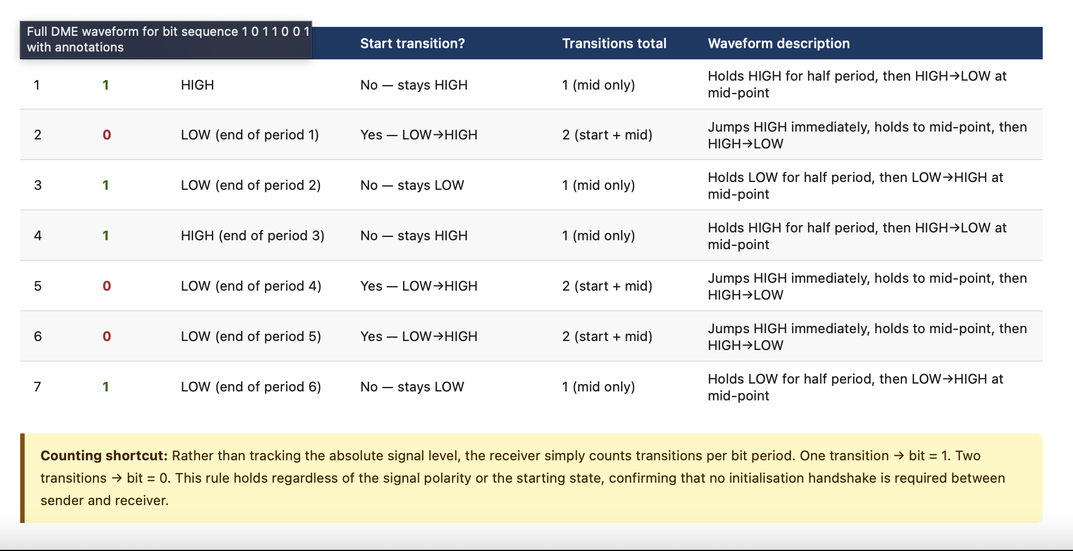
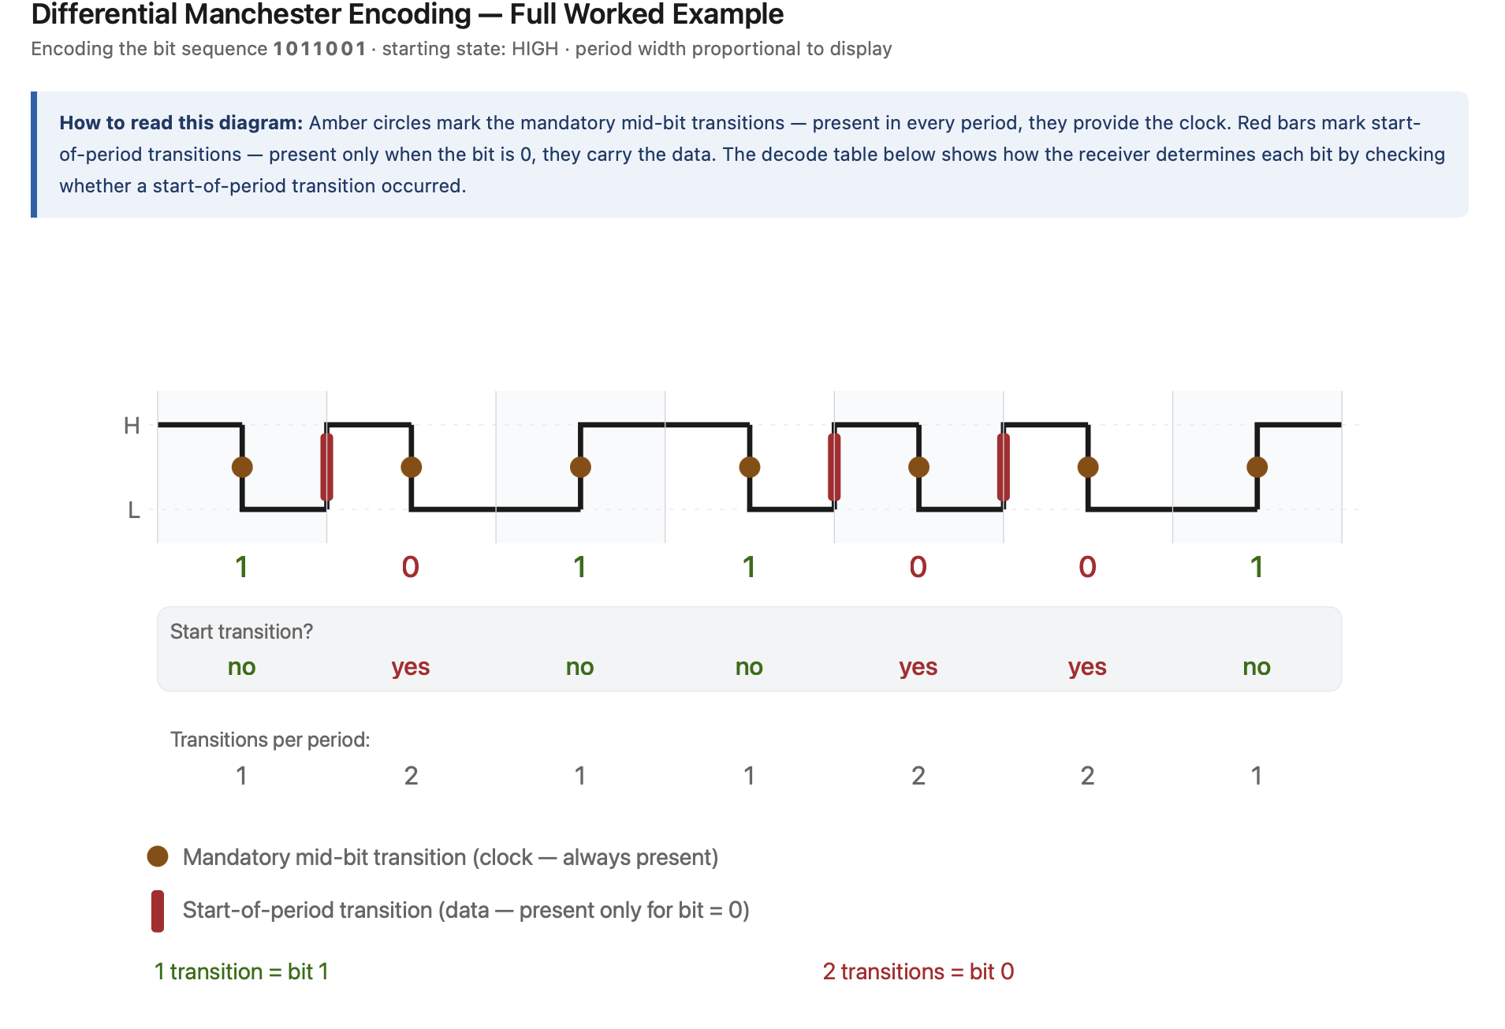

Reading the decode table directly: wherever you see "yes" for a start transition, that bit is a 0. Wherever you see "no", that bit is a 1. The mid-bit transitions (amber circles) are present in every single period — they provide the clock but carry no data.
A useful shortcut emerges: count transitions per period.
One transition = 1. Two transitions = 0.
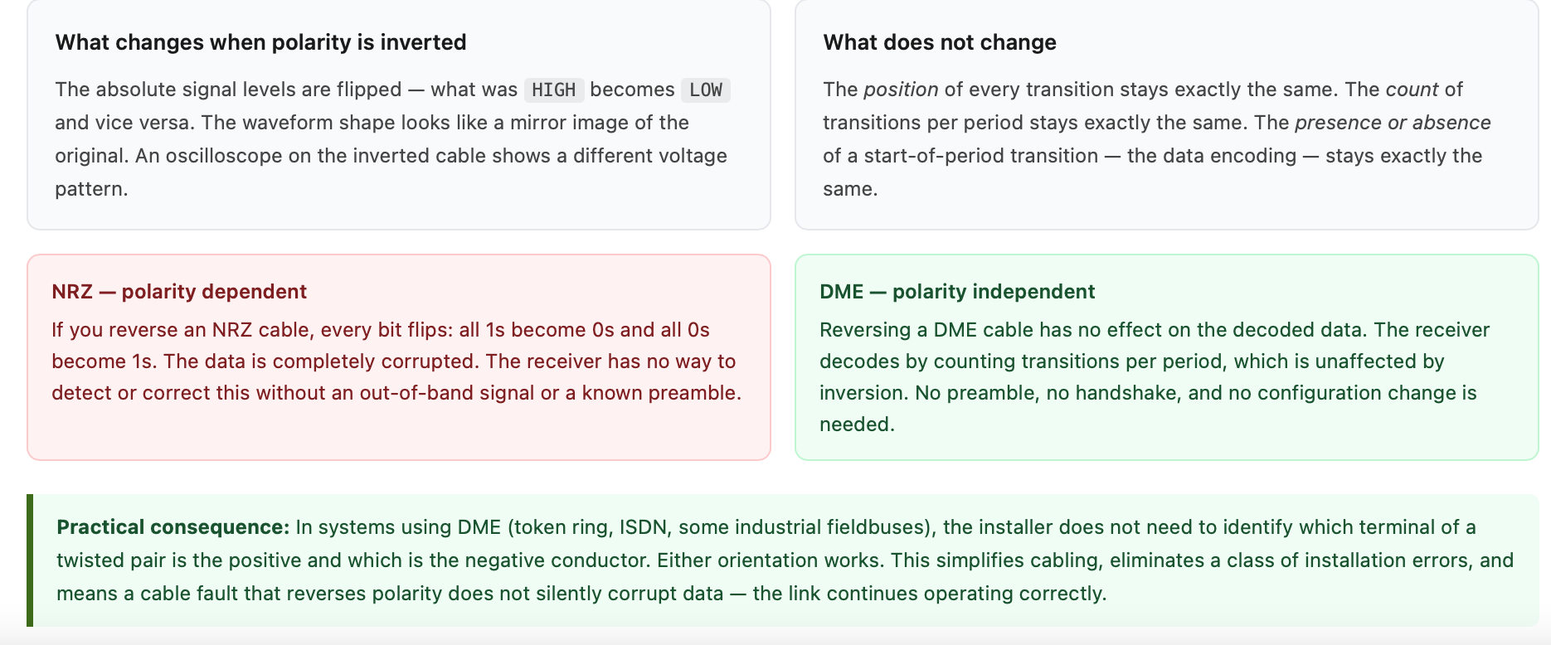
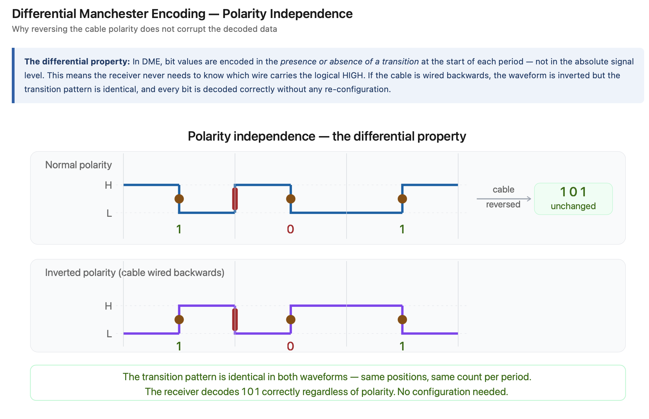

Interactive encoder — try your own bit sequence
Interactive Encoder

The four key properties — why DME is used
Property | How DME achieves it
Self-clocking | The mandatory mid-bit transition in every period gives the receiver a clock edge to lock onto, regardless of the data content
Polarity independence | Bit values are encoded in the presence or absence of a transition, not in signal level — inverting the signal does not change the decoded bits
DC balance | Every bit period contains at least one transition, ensuring equal time at HIGH and LOW over any sequence — no DC component accumulates
Bounded transitions | A 1 produces one transition per period; a 0 produces two. The maximum transition frequency (all-zeros sequence) is exactly twice the bit rate, which bounds the required signal bandwidth
DME is used in token ring networks (IEEE 802.4 and 802.5), ISDN, and various industrial fieldbuses.
In the context of the automotive Ethernet materials you have been studying, understanding DME also gives intuition for why 100BASE-T1 and 10BASE-T1S moved to more bandwidth-efficient PAM3 line codes — PAM3 encodes more bits per baud and eliminates the factor-of-two bandwidth overhead that differential encodings like DME carry.

